Route 33 - Rearsby Mill, Park Hill Golf Course, Ratcliffe College, Cossington - 9m

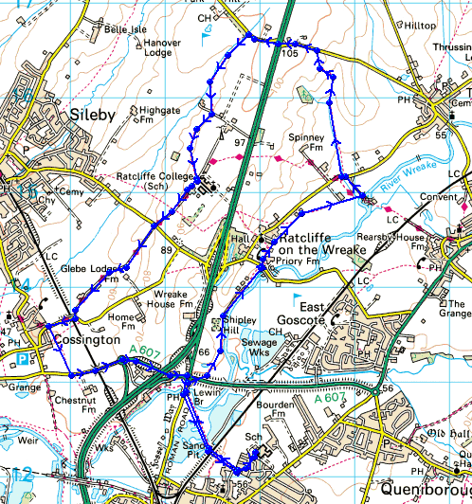

- Over the fields to the Gate Hangs Well pub
- Right at the road then immediately right again over the fields to Ratcliffe Mill
- Straight across the road on to the footpath to Rearsby Mill
- Left at the Mill Drive to reach the main Ratcliffe – Thrussington road
- Take the footpath straight over and stay on this path till you reach the road
- Left up the road to join and then cross the A46 (Be careful !!)
- Take the road to Seagrave for a while but then just after the bend, take the footpath on the left
- Cross over the golf course and fields to get back to Ratcliffe College drive.
- Right, to the Ratcliffe – Sileby road
- Go straight over into Blackberry Lane and run down into Cossington Village
- After crossing the railway bridge, turn left on the footpath
- Over the field to reach the road.
- Left along the road back to the Gate Hangs Well pub
- Over the fields and railway back to the College

