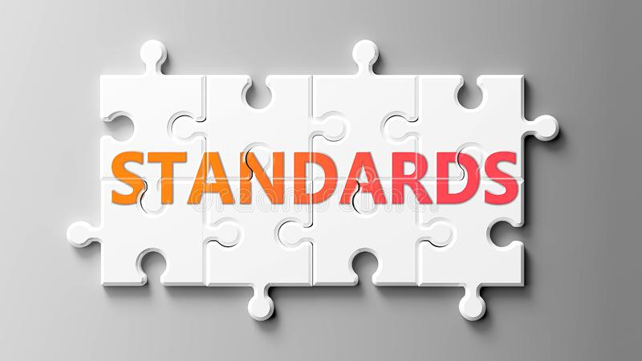

Club Standards 2024
The Standards run from 1st January 2024 to 31st December 2024.
This scheme covers a wide range of abilities and distances and will hopefully help motivate more people to improve their running. Certificates are issued on the basis of performances at 5 distances (9 for distinction) over the course of a calendar year. To qualify, you must run your time/chip time in a recognised race with an accurately measured course. OR, you can submit an ‘elapsed’ time from a Virtual Race or a solo run (Wreake Standards only). For Virtual, you cannot submit a time from part of a longer run.
Standard times are those for the age you were on race day.
Two versions of the Standards are available:
1. Wreake Runners Club Standards – A mix of Race and Virtual times allowed
2. Leicestershire Running and Athletics Network (LRAN) – Race times only.
If you want both Certificates you need to be aware of the differences
Race/Chip times – 5k distance (specifically Parkrun) – LRAN only recognise Watermead, Leicester Victoria Park, Abbey Park and Braunstone Park as these are accurately measured courses and any 5k official race. Wreake recognise any Parkrun, any 5k official race and our own 5k track time trial.
If you achieved your Standards in 2023, can you go one better and get to the next level up? And if you didn’t, get on it in 2024.

